Volunteers for Enhancing development

Jan Jagruti Foundation Proposal :

Child name : Yash Vijay Tambe, school left , 2018, at 2nd Standard. Father dead: 6 August, 2020, working as security guard at Dadar, residing at Q-303 regency , lodha heavan. Dombivili. Help required to pay out standing 12,000 INR/actual. To get LC for admission donation 10,000 INR if required. Other expense will at actual; will be borne by JJF. Your support will be appreciated.
Mr. GS Mallappa (chairman JJF) will share death certificate, fee outstanding if given, id card father. Total estimated budget is Rs. 25,000/as actual. Picture of the Student with his family shared:

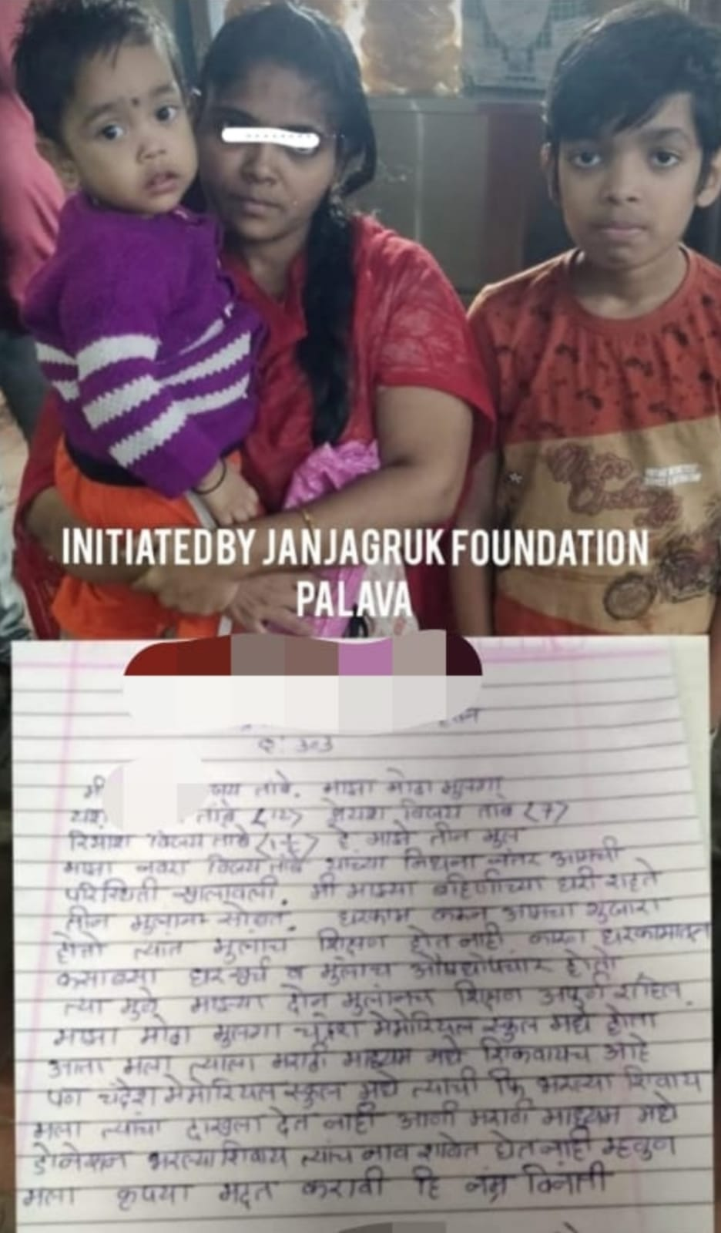

Proposal Review: Proposal reviewed with Board Members with following details:

1. Confirming the above facts and figures like Children current status, Aadhar card details of, ID Card of Father, Death Certificate and other financial details.

2. Face to Face meeting of Mr. Mallappa, honorable chairman of JJF and Mr. Rahul Srivastava, honorable Founder and Chairperson of VED to review the topic, it was envisaged that at present JJF is facing financial challenge to support the above case due to various ongoing programs of JJF.

Proposal Reviewed and Support from VED through its different channels agreed.

Board Members:

1. Rahul Srivastava
2. Himanshu Dwivedi
3. Chandra Gupta Srivastava
4. Ahbar Khan

